**README.md Guidelines**

⦁ **Introduction:**

- The full project include 2 parts Fontend and Backend.

- The Front end is build using ReactJS

- The Backend is build using Java Spring boot and PostgreSQL for the database storing

⦁ **Prerequisites:**

- Because both the Frontend and the Backend were both packaged in Docker technology, so to run the project on the local computer you need to have Docker installed on your computer. Depend on your operation, you can Docker Desktop correspondingly to install on your computer.

⦁ **Installation & Configuration & Running the Application:**

* Backend:
* Install git
* Create Backend folder
* Open cmd in the Backend folder
* Run the command: git clone https://github.com/TruongLy12/YouTubeSharing_Backend.git
* run the command docker-compose up –build
* Frontend:
* Create Frontend folder
* Open cmd in the Frontend folder
* Run the command: git clone https://github.com/TruongLy12/YouTubeSharing_Frontend.git
* run the command docker build -t myapp .

⦁ **Database Setup:**

- No database setup required

⦁ **Usage:**

- When you run the Frontend and the Backend in the Docker Container successfully, you now can open your browser at the address: http://localhost:3000/register to create an account for start using the program.

Each created account will have an unique email address and a non-empty password.

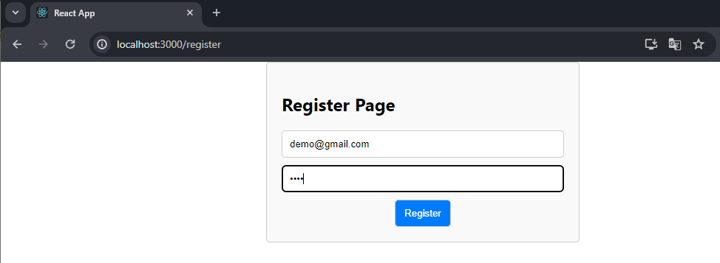

- When you successfully registered the account, now you can go to http://localhost:3000/register to login with the your created account.

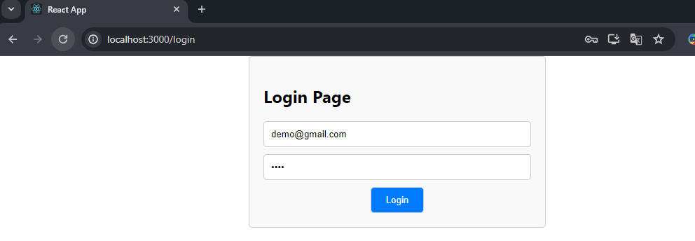

- After login, you can see a list of shared video by all users in the past. You now can start to share the youtube video to other account that currently logined.

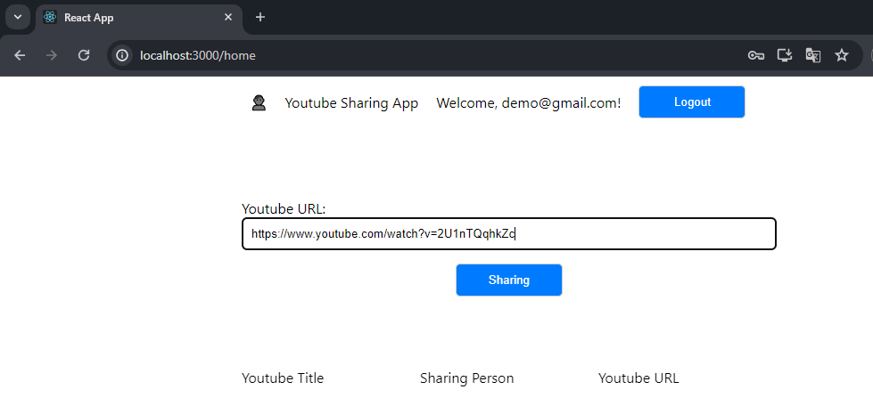

After click Sharing button, other account will have a notification about your video you just shared

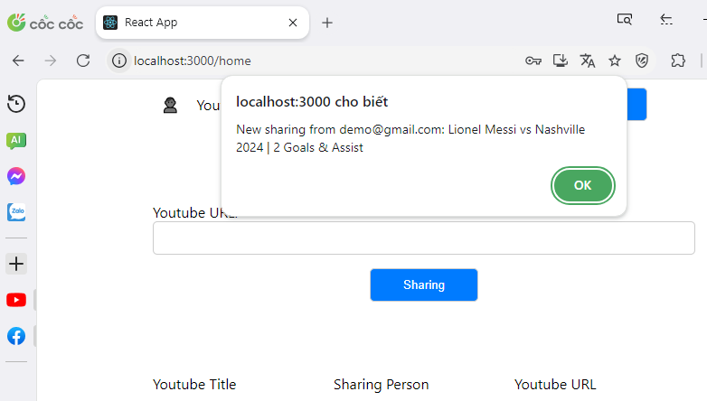

Now they can see the video just shared in the list

